Open Git Extension tool, if you have not downloaded get it from here

<https://sourceforge.net/projects/gitextensions/>

Once you download the tool, launch it and follow the steps below

* **Click on clone repository**

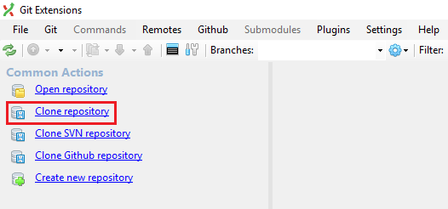

* **Fill all the details as shown below and then click on Clone button**

<https://github.com/NMM-IT-Team/NMMWebSite.git>

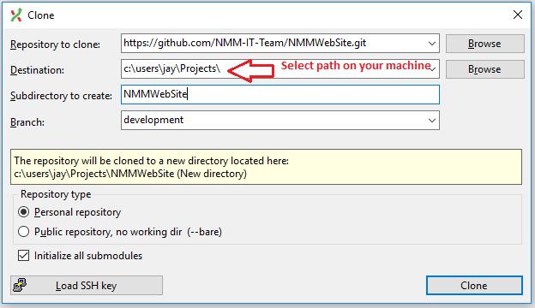

Development is the branch you will always be working on. All the website development you do will be done on the files in your destination directory.

For eg: If I am modifying sankashti.html, then I will be doing that in c:\users\jay\projects\NMMWebSite directory.

You should see screen similar to like the shown below.

